Villa, Joshua Alexander B.

2-ECE-C

1. isWordGuessed

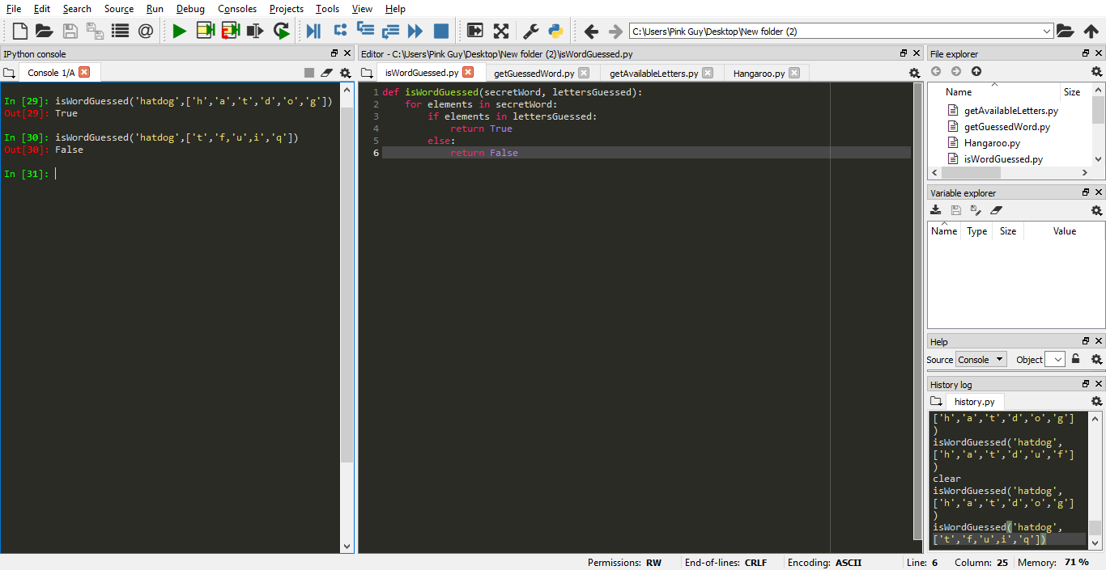

2. getGuessedWord

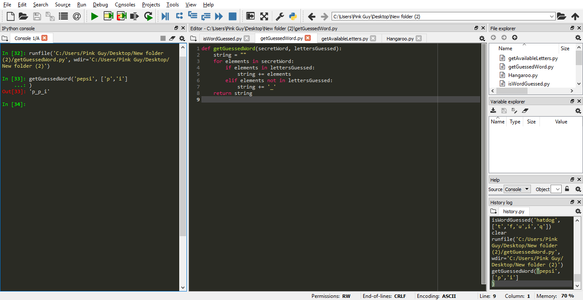

3. getAvailableLetters

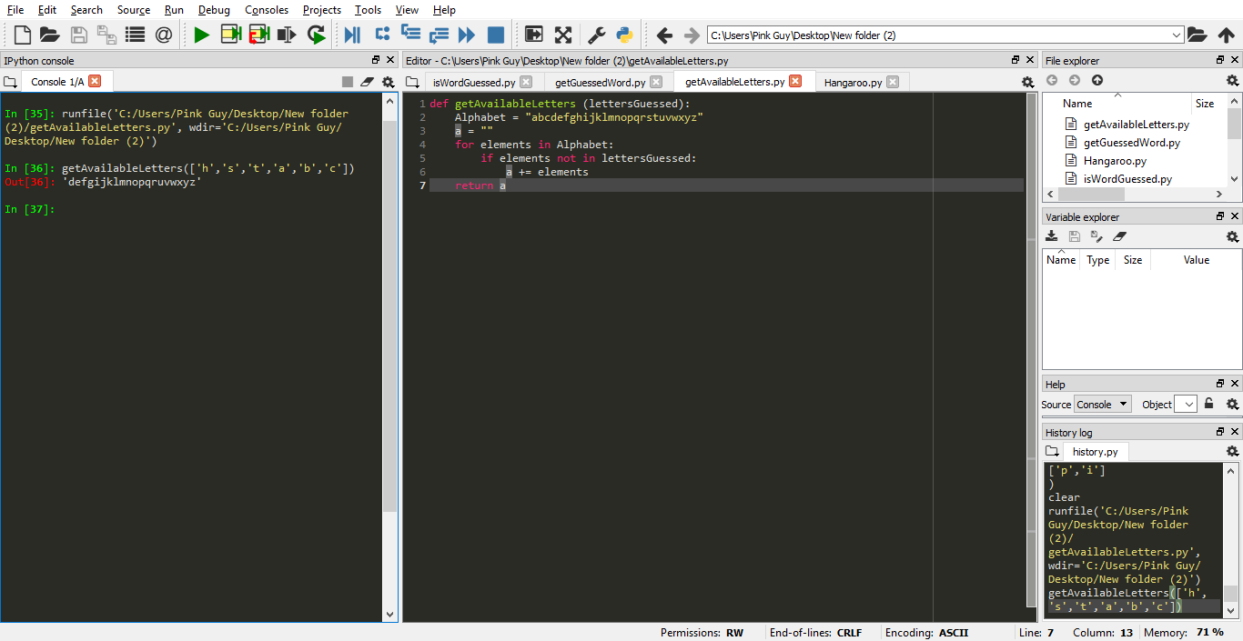

4. Hangaroo

